1. Which are the top three variables in your model which contribute most towards the probability of a lead getting converted?

Based on the coefficient values, the following are the top three variables that contribute most towards the probability of a lead getting converted -

* Tags: Top variable to identify potential hot leads, especially identify
* Lead source (It is the important feature which should be focused)
* Time spent on website (Positive contribution - Higher the time spent on the website, higher the probability of the lead converting into a customer)

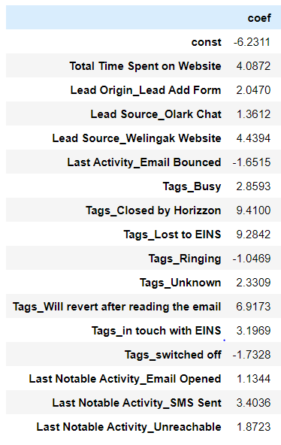

1. What are the top 3 categorical/dummy variables in the model which should be focused the most on in order to increase the probability of lead conversion?

Based on the coefficient and VIF values, the following are the top categorical variables that contribute most towards the probability of a lead getting converted -

* Tags_Will revert after reading the email
* Last Notable Activity_SMS Sent
* Lead Origin_Lead Add Form

1. X Education has a period of 2 months every year during which they hire some interns. The sales team, in particular, has around 10 interns allotted to them. So during this phase, they wish to make the lead conversion more aggressive. So they want almost all of the potential leads (i.e. the customers who have been predicted as 1 by the model) to be converted and hence, want to make phone calls to as much of such people as possible. Suggest a good strategy they should employ at this stage.

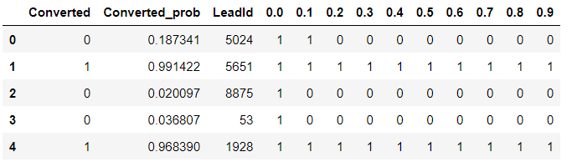

Cut off point of 0.25 can be considered optimal

During the two-month intern hiring phase at X Education, where the sales team is equipped with 10 interns, an effective strategy to aggressively boost lead conversion can be devised:

Begin by identifying potential leads using key variables such as Tags, Lead Source, and Time Spent on Website. The customers which should be contacted are the customers whose "Lead Score" is equal to or greater than 85. They can be termed as 'Hot Leads'.

To drive aggressive sales, initiate contact with all leads whose conversion probability is 1 and falls below the 0.25 cut-off. Create a comprehensive lead scoring model that factors in Time Spent on Site, Total Visits, and Lead References to refine lead prioritization.

Empower interns with a readily available conversion model encompassing key variables. Train them in consistent, personalized communication, starting with SMS and calls. This builds familiarity, enabling deeper discussions on backgrounds, challenges, and finances. Cultivate an environment where interns grasp the platform's value and convey its potential confidently. Focus on success stories and benefits to nurture leads' confidence. Through persistent, empathetic interactions, interns should demonstrate the platform's ability to address needs and enhance their professional journey.

Continuous follow-up and feedback, along with data-driven insights, refine the strategy iteratively. By synergizing intern efforts, data analysis, and personalized outreach, X Education can realize aggressive lead conversion, capitalizing on intern enthusiasm to convert potential leads effectively.

1. Similarly, at times, the company reaches its target for a quarter before the deadline. During this time, the company wants the sales team to focus on some new work as well. So during this time, the company’s aim is to not make phone calls unless it’s extremely necessary, i.e. they want to minimize the rate of useless phone calls. Suggest a strategy they should employ at this stage.

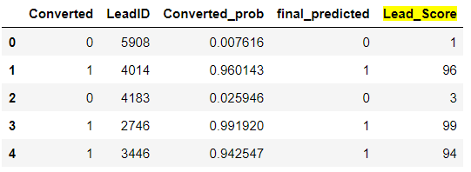

During a quarter when the company achieves its target early, a strategy to minimize unnecessary phone calls involves prioritizing outreach effectively. Firstly, contact leads with a lead_score below 75, ensuring efficient resource allocation. Although some converted leads might be missed, the achieved target mitigates concerns.

Secondly the company should focus on the variables which leads to higher conversion of leads and try to ensure that the customers are engaged strategically like encouraging them to spend more time on the website, send emails with relevant course information and questions, etc.